**Snow depths from the heights: developing a mission-specific civilian unmanned aircraft system for sensing the mountain snowpack**

By

Jessica Lundquist

Edward McCormack

Francesca White

Kris Gauksheim

Juris Vagners

Civil and Environmental Engineering

Aeronautics and Astronautics

University of Washington, Box 354802

Seattle, Washington

Prepared for the

Joint Center for Aerospace Technology Innovation (JCATI)

June 30, 2013

[Introduction 1](#_Toc359579505)

[Snow Applications – what is needed 1](#_Toc359579506)

[Current state of operations 1](#_Toc359579507)

[Avalanche operations (WSDOT) 1](#_Toc359579508)

[Potential Payoff for Practice 3](#_Toc359579509)

[Snow surveys (NRCS) 5](#_Toc359579510)

[Specific water supply/hydropower agencies 6](#_Toc359579511)

[Summary of prior work on remote sensing of snow 6](#_Toc359579512)

[Gamma 7](#_Toc359579513)

[LiDAR (Light Detection and Ranging) 7](#_Toc359579514)

[Synthetic Aperature Radar (SAR) and Microwave remote sensing 8](#_Toc359579515)

[Visual (EO) 8](#_Toc359579516)

[Near-Infrared (NIR) 10](#_Toc359579517)

[Infrared (IR) 10](#_Toc359579518)

[What is required to make UAS feasible for operations 10](#_Toc359579519)

[Sensor Packages for Aerial Snow Sensing 11](#_Toc359579520)

[Flexrotor specifications and applications 11](#_Toc359579521)

[Sensor summary 12](#_Toc359579522)

[Manned Test Flight 18](#_Toc359579523)

[Instruments, aircraft, flight details 18](#_Toc359579524)

[Results 19](#_Toc359579525)

[Discussion 21](#_Toc359579526)

[FAA requirements for UAS (and how they affect feasibility) 21](#_Toc359579527)

[Further research needs 22](#_Toc359579528)

[Testing on the UAS 22](#_Toc359579529)

[Testing of the sensors 22](#_Toc359579530)

[Testing by the management agencies 23](#_Toc359579531)

[Summary 24](#_Toc359579532)

[References (sorted) 25](#_Toc359579533)

[References (unsorted) 30](#_Toc359579534)

[Table 1 (reprinted from Foster et al. 1984). Current and future needs of snow information. 2](#_Toc359581241)

[Table 2: Sensor Feasibility Summary 14](#_Toc359581242)

[Table 3: Thermal Infrared Camera Specifications and Costs 15](#_Toc359581243)

[Table 4: Near Infrared Camera Specifications and Costs 16](#_Toc359581244)

[Table 5: Visual Infrared Camera Specifications and Costs 16](#_Toc359581245)

[Table 6: Nikon Lens Options for D800 DSLR 16](#_Toc359581246)

[Table 7: Examples of using different pixel options and flight elevations 17](#_Toc359581247)

[Table 8: Cost of Additional Photogrammetry Instruments 18](#_Toc359581248)

[Table 9: GPS and GPS Accessories for Photogrammetry 18](#_Toc359581249)

[Table 10: LiDAR Specifications and Costs 19](#_Toc359581250)

[Table 11: Gamma Radiation Specifications and Costs 19](#_Toc359581251)

[Table 12: Synthetic Aperture Radar Specifications and Costs 20](#_Toc359581252)

# Introduction

Unmanned aircraft systems (UASs) are a relatively new technology that has resulted from improved global positioning systems (GPS), better software, smaller computers and sensors, and material advances such as carbon fiber airframes. UASs have become smaller, more capable, and less expensive mainly because of military investment in the UAS industry. Current generation UASs can be transported in small vehicles and launched from a road or a small truck but are still large enough to be equipped with cameras that can provide high quality aerial information and can carry significant payloads such as sensors or charges for bombing avalanches. In addition, these aircraft are capable of flying without direct human input, autonomously completing preset flight plans. These capabilities have generated considerable interest in civilian applications of UAS, including for environmental sensing needs. This Joint Center for Aerospace Technology Innovation (JCATI)-funded project explored the use of UASs for the collection of snowpack data to support snow applications for avalanche control operations and water resources analysis.

## Snow Applications—What Is Needed

For water resource applications, managers need to quantify how much snow is in the mountains. At a point on the ground, this is typically achieved by weighing the snow. Aerially, this can be accomplished by mapping snow depth (with LiDAR or with visual references) and by assuming spatially uniform snow density (Sturm et al. 2010), or by measuring some property that is attenuated by the water content within the snow (through gamma radiation or microwave). Snow quantity can also be estimated by modeling snow accumulation and melt, but errors in and calibration of the model are fundamental weaknesses. Therefore, observations that can be used to improve snow modeling, even if they are not direct measurements of snow water equivalent, are also valuable. These include snow state measurements (such as snow surface temperature or albedo) that can be used for spatial model validation and calibration, and energy balance measurements (such as atmospheric temperature, humidity, wind, incoming longwave and shortwave radiation) that can be used to improve the estimates of when, where, and how fast snow melts.

For avalanche operations, managers need to know where and when snow is likely to slide. This requires detailed knowledge of not only where and how much snow has accumulated in the area but also of the structure of the snowpack, including thermal and granual gradients or buried hoar frost. Table 1 details major uses of snow information for various applications.

Table 1. Current and Future Needs of Snow Information (reprinted from Foster et al. 1984).

## foster_table1

## Current State of Operations

### Avalanche Operations

A number of western states, including Washington state, have important travel corridors that cross mountainous terrain and over high-altitude passes. In the winter, keeping these roads open for safe and reliable winter travel requires that state DOTs operate avalanche control programs to both monitor snow conditions and trigger controlled avalanches before enough snow accumulates to create large and destructive snow slides. These avalanche control operations, while necessary to keep roads open, are costly, potentially dangerous, technically complicated, and time consuming.

Current avalanche control efforts involve a range of methods to trigger avalanches. DOTs may use surplus military tanks and howitzers that shoot explosives into avalanche prone areas, skiers or snowmobilers with handheld explosive charges, and, occasionally, airplanes or helicopters that drop charges. Each of these methods, while effective, is costly and can be dangerous if not used carefully. As a result, many mountain roads have to be closed for lengthy periods until avalanche control operations have been completed. These unpredictable closures can have notable negative economic impacts for both people and freight mobility.

This Joint Center for Aerospace Technology Innovation program application, in part, explored the use of small unmanned aircraft as an additional tool for DOT avalanche control staff that will help them open roadways more quickly.

As noted above, small civilian versions of unmanned aircraft systems are increasingly affordable and easy to operate. Recognizing their potential, in 2006 and 2007 the Washington State Department of Transportation (WSDOT) and one member of this UW project team tested the use of both rotary (helicopters) and fixed-wing UASs in Washington state as a tool to support avalanche control operations. These initial proof of concept tests demonstrated that UASs have the potential to carry sensors and cameras to provide high quality aerial information about snow conditions both on and alongside roadways, inspect avalanche control target zones for people before the use of explosives, and accurately drop charges to trigger snow avalanches to support snow avalanche control operations. The findings also suggested that unmanned aircraft can improve the safety, effectiveness, and speed of avalanche control operations by reducing avalanche control personnel response time while also increasing safety for motorists and control staff. The project also determined that UASs are both affordable and operable by a state DOT. More information on these tests can be found in McCormack (2008 and 2009) and McCormack and Stimberis (2010a and 2010b).

These limited, initial UW/WSDOT flights, which were funded by WSDOT and the U.S. DOT, showed the promise of this technology. This JACTI project supported a continuing evaluation of the UAS technology as a tool to benefit organizations responsible for maintaining roadways in winter conditions.

#### Potential Payoff for Practice

Many western states have major roads that travel through avalanche prone areas. Table 2 shows the locations of major travel corridors that require state DOTs to manage avalanche control operations.

Table 2. Roadways Requiring Avalanche Control Operations

|  |  |
| --- | --- |
| **Avalanche Hazards on the National Highway System:** | |
| Alaska | SR9 on the Seward Highway from Anchorage |
| R7 north of Juneau |
| California | 80 at Donner Summit |
| SR 50 at Econ Summit |
| R 88 at Carson Pass (California side) |
| R 120 at Yosemite National Park |
| Colorado | 70 at the Eisenhower Tunnel |
| SR 550 at Red Mountain |
| SR 160 at Wolf Creek Pass |
| Montana | SR 89 at Glacier National Park |
| SR 2 at Marias Pass |
| Nevada | SR 88 at Carson Pass (Nevada Side) |
| Utah | 84 in Ogden Canyon |
| SR 189 in Provo Canyon |
| Washington | 90 at Snoqualmie Pass |
| SR 2 at Stevens Pass |
| USR 12 at White Pass |
| US 20 in the North Cascades |
| Wyoming: | SR 89 at Yellowstone National Park |
| SR 14 at Yellowstone National Park |
| SR 189 in Hogback Canyon |
| Source: Revised from Winter Alpine Engineering (2004) | |

Avalanche control programs (typically part of state DOTs’ maintenance and operations) focus on keeping a state’s important travel corridors through the mountains open during winter conditions and, for some states, on protecting maintenance crews re-opening and plowing roadways in the spring. State avalanche control operations are often expensive. One report calculated that state DOTs spent more than $6 million each year (Winter Alpine Engineering 2004). The WSDOT’s avalanche control budget just to keep the three major cross-Cascade highways open (I-90, SR 20, and SR 2) is $2 to $4 million per year (WSDOT 2013a).

There are usually few problems justifying a DOT’s control program from a cost perspective because any closure of a roadway is often considerably more expensive than a control program. In Washington, Interstate-90, the state’s major east-west travel route, crosses Snoqualmie Pass in the Cascade Mountains. Between 2007 and 2013, this pass was closed an average of about 100 hours a year because of avalanche threats and resulting control activities (WSDOT 2013b). WSDOT has estimated that each hour that I-90 is closed costs about $500,000 to the state’s economy. The winter of 2007-2008 had notably heavy snowfall, and the pass was closed for over 600 hours. During that winter, one four-day closure was estimated to cost the state $28 million (WSDOT 2008). That closure had a major impact on the freight community, since many stores and manufacturing processes require frequent and reliable deliveries. On a typical day the pass serves 6,500 trucks. During the four-day closure, because an alternative route through the Cascade Mountains (SR 2) was also closed for avalanche control operations, hundreds of trucks were lined up waiting for the pass to open.

Avalanches occur when snow on a slope or in chute can no longer support its own weight, loses grip on a slope, and slides downhill. Such avalanches can be extremely powerful and can travel surprisingly long distances. There are numerous examples of cars and large trucks being pushed off the road, with occasional fatalities. Current avalanche control efforts involve surveying snow conditions to identify conditions conducive to slides, clearing the run-out zone of people and hazards, and then purposefully triggering smaller controlled avalanches before snow can accumulate to dangerous amounts. This process is part art and part science, and it involves identifying when and where to trigger an avalanche slope or chute. Often this involves using a range of methods to deliver explosives to set off the avalanche. DOTs use surplus military tanks and howitzers to shoot explosives into avalanche prone areas, skiers or snowmobilers to deliver handheld explosive charges, and sometimes helicopters or airplanes to bomb avalanches. Each of these methods has limitations and is expensive, slow, and involves some risk to humans or may require increasingly difficult to obtain military equipment.

Small unmanned aircraft offer an alternative method both for surveying snow conditions and avalanche areas and for triggering controlled avalanches that potentially could be quicker, safer, and less costly than existing methods.

Previous tests with these smaller UASs conducted by this project’s researchers indicated that this technology can repeatedly deliver dummy control explosives with 6-foot accuracy to predetermined locations. Avalanche control professionals, through experience, often know the locations of trigger zones. (Many of their howitzers and tanks are pre-sighted to set locations.) One notable advantage of a UAS, operating out of a DOT maintenance vehicle, is that it could deliver the explosive charge to the same pre-determined locations without requiring increasingly difficult to obtain and secure military equipment or sending out skiers or snowmobilers. The use of skiers or snowmobilers often requires a human to make a sometimes dangerous and often slow trip to a trigger zone. Because UASs fly autonomously (without direct human control), they could potentially deliver control explosives with great accuracy and with minimal human risk or discomfort. This could result in roadways opening much sooner.

An obvious use of UASs is to replace a manned aircraft. WSDOT contracts manned aircraft for avalanche control, but this is limited because the aircraft are costly. Hiring a helicopter, for example, can cost WSDOT $800 to $1,000 an hour (McCormack and Stimberis 2010). Operations involving “bombing” avalanches can also place the pilot and crew at risk. These aircraft and pilots are also not always immediately available, which can delay control operations and the ability to open roadways.

### Water Supply, Hydropower, and Snow Surveys (NRCS)

The Natural Resources Conservation Service (NRCS) is the primary agency responsible for assessing the snow water stored in the mountain snowpacks of the western United States. In most cases, the local agency responsible for a watershed (or with a vested interest in a given snow water supply forecast) partners with the NRCS in maintaining SNOTEL sites and conducting snow surveys, including shouldering part of the cost for measurements collected and instrument maintenance. Specific operations and needs for additional information vary among watersheds and management agencies. For example, Seattle City Light is particularly interested in monitoring glacier change in the Skagit watershed, and Seattle Public Utilities, which owns its entire watershed, is interested in forest management for overall watershed health. In very large reservoir systems, e.g., the Colorado River, reservoirs can store more than a year’s worth of runoff, so the total annual water supply is much more important than runoff timing. However, in watersheds with relatively small reservoirs, runoff timing (i.e., snowmelt timing) is more important, particularly when these reservoirs must also be managed for fish protection.

Most snow surveys are conducted manually, by human observers probing and weighing the snow. However, the NRCS and their cooperators also use aerial snow markers as one method to measure the depth of the snow. In the state of Washington, there are both permanent and temporary markers. Permanent markers consist of a 3-inch steel pipe that is cemented into the ground. A series of metal paddles—6 inches high, 2 feet long, and 2 inches thick—are secured to the pole 6 inches apart (Pattee 2013). Temporary markers consist of the same type of paddle, but they are secured to existing meteorological towers. The measures taken with aerial markers are not as accurate as those taken by physically measuring snow depth with a probe on the ground because the measurements are in 6-inch increments. However, they provide beneficial results for areas that are distant and difficult for people to access on the ground at a reasonable cost (Julander 2012).

According to the NRCS Washington Snow Survey Measurement Schedule for water year 2012, of the 18 cooperators to conduct snow surveys, two used aerial markers. These two included Bellevue PSP & L, which measured all nine stations with aerial markers (Dock Butte, Easy Pass, Jasper Pass, Marten Lake, Mt. Blum, Rocky Creek, Scheibers, S.F. Thunder, and Watson Lakes) and Chelan PUD, which measured three stations with aerial markers (Cloudy Pass, Little Meadows, and Park Creek Ridge) (Pattee 2013). The snow surveys must be performed within five days before the first of each month, January through June. When the surveys are performed, a fixed wing aircraft or a helicopter flies over the snowfield, and a visual camera takes images of the stakes. Once the images have been processed, the paddles are counted and the snow depth is measured. In Washington, costs are approximately $2,000/hr (Pattee 2013). In Salt Lake City, Utah, and surrounding areas, approximately 18 sites currently use aerial snow markers. A snow survey takes about one full day with a flight time of approximately two hours. The cost per hour ranges from $1,600 to $2,000, depending on the aircraft (Julander 2013). The NRCS has also begun to incorporate automated snow markers in Utah. These systems use iridium satellite telemetry to provide measurements of snow depth and temperature four times a day. A standard temperature sensor, soil moisture/temperature sensor and a precipitation gauge will be added in the future, which will allow the automated snow markers to have all the capabilities of a standard snowpack sensor (SNOTEL), except for a snow pillow (Julander 2012). Each of these sensors is approximately $3,000 to $4,000.

These applications demonstrate that manned aerial snow surveys are valuable. This JACTI project supported an evaluation of the UAS technology as a tool to more efficiently complete these surveys.

## Summary of Previous Work on Remote Snow Sensing

Remote snow sensing has been researched for decades (see Dozier and Painter 2004; Nolin 2010; Deitz et al. 2012). Sensors detect electromagnetic waves that are either emitted by or reflected from the land surface. Figure 1 identifies which of these wavelengths are most useful for snow and how they have been used in the past. Specific sections below provide more details on each measurement.

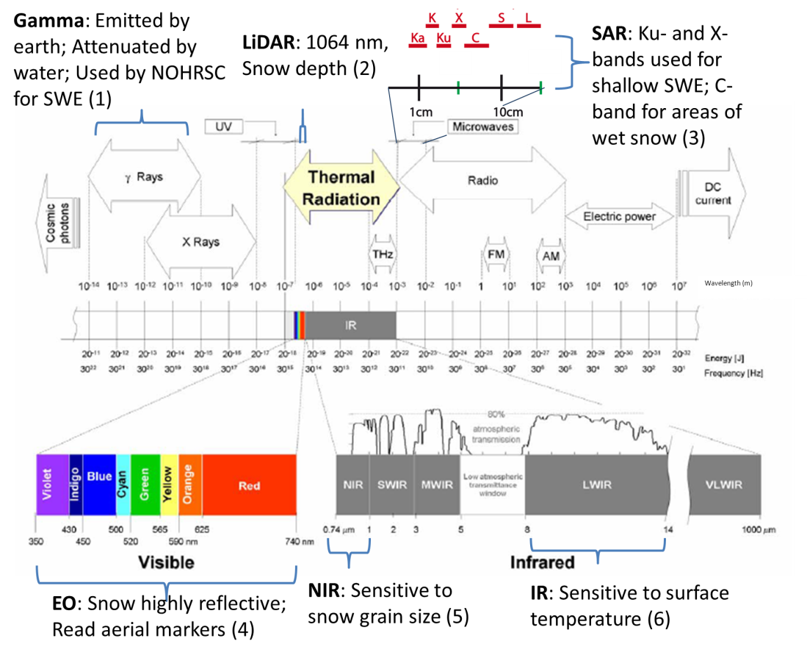

Figure 1. Guide to the electro-magnetic spectrum with relevance to snow. References detailing each waveband are as follows: (1) Carroll 2001; (2) Hopkinson et al. 2004, Deems et al. 2006; (3) Nolin 2010, Dietz et al. 2012; (4) Henderson 1953, Hannaford 1960, Miller 1962; (5) Tape et al. 2010, Matzl and Schneebeli 2006 ; (6) Shea and Jamieson 2011. [Base figure adapted from Ibarra-Castanedo 2005.]

### Gamma

The National Operational Hydrologic Remote Sensing Center (NOHRSC) conducts aerial snow surveys by flying an AC-695A jet prop commander aircraft 500 feet above the ground to measure snow water equivalent (SWE), which is the amount of water in the snow pack, as well as additional water content in the upper 8 inches of the soil (Carroll 2001). These flights cover more than 2000 pre-surveyed flight lines (Carroll 2001) over areas of Alaska, New England, the northern U.S. Great Plains, and some large river valleys in the western United States. To measure SWE, a gamma radiation detection system (RSX-5 from Radiation Solutions, weighing 114 kg) is mounted in the cabin of the aircraft. Water attenuates gamma radiation emitted by potassium, uranium, and thorium radioisotopes in the soil. By comparing measurements between snow-on and snow-off conditions, SWE can be determined. Flights for a given basin occur typically three or fewer times per year, and these measurements are typically combined with other snow data sources for water supply prediction (Carroll et al. 1999; Cowles et al. 2002).

### LiDAR (Light Detection and Ranging)

Airborne LiDAR is able to very accurately measure distances. When LiDAR data are combined with precise information about an aircraft’s altitude, pitch, roll, and yaw (such as can be obtained from an inertial navigation system, or INS), high-resolution (<1 m) digital elevation models can be created for the surface. When flights are repeated in both snow-off and snow-on conditions, the difference between these elevations provides a spatial map of snow depth with ~1-cm vertical resolution and ~1-m2 horizontal footprint (Hopkinson et al. 2004; Deems et al. 2006). NASA and the California Department of Water Resources are currently repeating flights of LiDAR to map snow in the Tuolumne River Watershed in California (JPL 2013).

### Synthetic Aperature Radar (SAR) and Microwave Remote Sensing

Synthetic aperature radar (SAR) is active microwave remote sensing. SAR instruments are typically mounted on the side of an aircraft, pointing from the horizon to straight down. Post-processing uses the correlation between phase shifts of all wavelengths returned to the aircraft or satellite, combined with records of the craft’s movement (generally from an inertial motion unit), to simulate an infinitely long phased array of sender/transceivers. The use of SAR in snow science is relatively new. C-band SAR instruments can map areas of wet snow and retrieve snow liquid water content (Nagler and Rott 2000; Pulliainen et al. 2004). Scatterometry can also map where snow is actively melting by using Ku-band measurements (Nghiem and Tsai 2001; Wang et al. 2008). Rott et al. (2010) combined Ku-band and X-band measurements to estimate SWE in Alaska.

Passive microwave remote sensing is available on many satellites and for global applications. However, these techniques work best for shallow snow (Deitz et al. 2012). Because this report is focused on the Pacific Northwest, which typically has deep snow, we will not further detail passive microwave remote sensing techniques.

### Visible (Electro-optical)

Snow is highly reflective in the visible wavelengths and so is easy to see in standard photography using visible wavelengths. The earliest applications were to visually read snow depth off aerial markers (Henderson 1953; Hannaford 1960; Miller 1962; Bruce 1967), as described previously (see Figure 2).

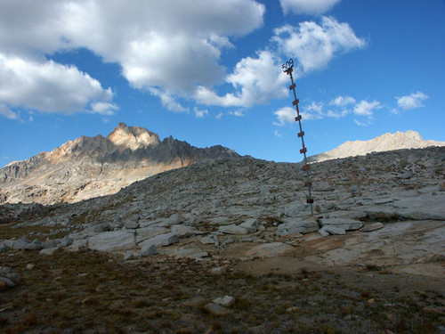 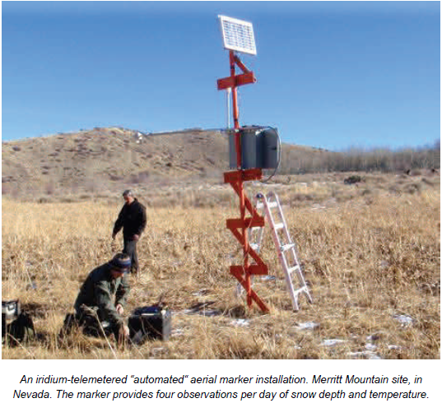

Figure 2. (left) Aerial snow depth marker in Humphreys Basin (near Cony Lakes and Mt. Humphreys) (from <http://www.summitpost.org/aerial-snow-depth-marker-in/28710>)  
(right) Aerial marker in Utah with iridium technology (Julander 2012).

Satellite imagery uses snow’s high reflectivity in the visible wavelengths (Figure 3) as a tool to identify snow-covered areas, and various algorithms exploit differential reflectivity across multiple wavelengths to identify fractional snow covered areas (e.g., ASTER, Vogel 2002; MODSCAG, Painter et al. 2009; and MOD10A1, Hall et al. 2006). See Deitz et al. 2012 for an excellent review of satellite-based optical sensors.

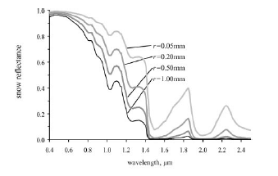

Figure 3. Snow reflectance as a function of snow grain size (r) and wavelength (from Figure 2 in Dozier and Painter 2004, which used the model of Wiscombe and Warren (1980) to generate the spectral reflectance). Snow is very reflective in the visible spectrum but not reflective in the near infrared.

Photogrammetry combines multiple visual images to recreate a 3-dimensional surface (Baltsavias 1999; Pollack 1965). These techniques, also termed structure from motion, have been applied in ecosystems/forestry sciences (Dunford et al. 2009; Järnstedt et al. 2012; Dandois et al. 2013), for the creation of digital elevation models (Fonstad et al. 2013), for glacier surveys (Welty et al. 2013), and for studies of geomorphology (Westoby et al. 2012). In many instances, an UAS has been flown to gather the visual imagery used in processing 3-D models (Wallace et al. 2012; Miller et al. 1998; Bryson et al. 2011) or to otherwise classify a subject of interest, ranging from archaeology to vegetation (Chiabrando et al. 2011; Sugiura et al. 2005; Laliberte et al. 2011).

### Near-Infrared (NIR)

The reflection of light in the near-infrared (NIR) wavelengths (0.75 to 1.4 µm) is sensitive to snow grain size (Dozier et al. 1981), and several researchers have used NIR cameras to map out snow stratigraphy and snow grain size (Matzl and Schneebeli 2006; Tape et al. 2010). These parameters are incredibly useful for avalanche forecasting. Most digital cameras are sensitive to NIR wavelengths but contain a filter to remove them from the photograph. With a change of filters, widely-available EO (electro–optical, i.e., visible wavelengths) cameras could be converted to NIR cameras.

### Infrared (IR)

Thermal infrared (IR) cameras focus on 7.5- to 13.5-µm wavelengths. Snow has less than 2 percent reflectance in the 6- to 10-µm bands but can have as much as 4 percent reflectance with coarse granular crust in the 10- to 12-µm bands (Salisbury et al. 1994; Dozier and Warren 1982). For practical purposes, many investigators assume that snow is a black body (an idealized physical body that absorbs all radiation) with an emissivity of 1 (e.g., Morin et al. 2012). Shea and Jamieson (2011) investigated snow surface thermography with a handheld camera (FLIR B300). Howard and Stull (2013, in press) used a FLIR E40 IR digital camera with a manufacturer-stated accuracy of ±2 percent (up to 6°C for their case study), with a spectral range of 7.5 to 13 µm, to determine the temperatures of trees near snow. They carefully corrected for atmospheric emission between the camera and the trees by recording the air temperature, the relative humidity, and the distance between the camera and the object.

## What Is Required to Make UASs Feasible for Operations?

For a UAS to be used for basic water resources applications, it must be more cost-effective than the cost of the salary and flight time of the people in a helicopter who visit sites and take human measurements. Because aerial IR imagery has not been historically available, further ground truth work (from a hand-held or pole-mounted camera) must be completed to demonstrate its economic value to avalanche and water resources applications. LiDAR measurements of cloud-points of surfaces have proved to be useful for snow water assessment (as in current operation in California), so if photogrammetry can provide information comparable to or even slightly less accurate than LiDAR, it would be favored as long as the cost (of both data collection and analysis) was less than that of LiDAR. The logistics of flying the UAS would need to be no more difficult than hiring a manned aircraft (such as an agency owning a UAS with in-house expertise and standing permission to fly over its watershed).

# Sensor Packages for Aerial Snow Sensing

## Flexrotor Specifications and Applications

This effort is a proof of concept using based on the capabilities of the Aerovel Corporation’s Flexrotor. This UAS is a 19-kg (42-lb), 3-m (10-ft) wingspan aircraft capable of flying for more than 40 hours with a 0.9-kg (2-lb) payload (<http://www.flexrotor.com/>). Flexrotor is capable of both efficient wing-borne cruising and helicopter-like hovering, enabling vertical take-off and landing (VTOL) from sites with limited access or space. Portability is aided by small size, light weight, and the VTOL characteristics. Currently under development, Flexrotor has demonstrated autonomous flight, including automatic VTOL (<https://www.youtube.com/watch?v=M6Lq2BJtYvY>). Flexrotor has been equipped with a Hood Technology stabilized video camera imaging system, mounted in the nose bay forward of the rotor/propeller (<http://www.auvsishow.org/auvsi12/public/Booth.aspx?IndexInList=&Upgrade=&FromPage=&BoothID=103831&Task=PressReleaseDetails&PRID=377>).

Sensor payload integration for Flexrotor, or indeed any aircraft, involves a number of factors, perhaps the most obvious of which is payload mass. Payload integration involves more than just the capability to carry mass. The payload must be mounted so that the resulting drag characteristics—weight and balance, etc.—allow acceptable aircraft performance and control for the desired mission. Furthermore, the sensor payload must be given a satisfactory view of the sensor target environment and be able to operate effectively in the aircraft load and vibration environment, and both payload and aircraft must be capable of tolerating electromagnetic interference. Mounting options on Flexrotor include a non-rotating nose bay forward of the rotor/propeller, providing a low-drag payload location with a more than hemispherical view of the environment (<http://www.aerovelco.com/images/FlexrotorThreeView-1.gif>). The payload must also have sufficient electrical power, an interface for command and status messages, and capability for recording and/or transmitting sensor data. Motorized gimbals may be necessary or desired for stabilization, pointing, or sensor operation in multiple aircraft attitudes.

There are options if multiple sensor packages are desired. One aircraft may carry all of the sensors, or multiple aircraft can be used, with each carrying a subset of the desired sensors. An alternative is to add or remove sensors as required. For example, Flexrotor may use swappable nose modules containing either a visible or IR camera. This last option will allow the selection of sensor(s) appropriate for the mission, or possibly different sensors in consecutive flights.

A small aircraft such as Flexrotor is not capable of carrying heavy sensor packages, but it may compensate for this by flying a lighter, reduced-capability sensor closer to the sensor target. This can be achieved because of the smaller risk in comparison to a manned aircraft or because of the smaller size and slower speed, including capability for hover. An aircraft capable of flying closer to terrain may potentially fly “below the weather” in conditions unavailable to other aircraft because of safety or sensor view concerns.

Ideally, a mission-specific UAS would be sized and designed for the mission and associated sensor packages. However, the cost and effort involved would be prohibitive, especially for a proof of concept or small market. Given these issues, an existing aircraft capable of being adapted to economically perform the desired mission could be the best and indeed only choice.

## Sensor Summary

One of this project’s tasks was to select or design sensor packages. Several sensors were evaluated to determine the feasibility of using them in UASs, given the specifications discussed in the previous subsection. These sensors included thermal and near infrared cameras, visual cameras, LiDAR, synthetic aperture radar (SAR), and gamma radiation. This section discusses the appropriate uses, specifications, and limitations of each instrument. Table 3 summarizes the sensors that were evaluated and the conclusions about the feasibility.

Table 3: Sensor Feasibility Summary

|  |  |  |
| --- | --- | --- |
| **Sensor** | **Feasible?** | **Limitations** |
| Thermal IR Camera | Yes | --- |
| Near IR Camera | Yes | --- |
| Visual Camera | Yes | --- |
| Visual Camera Accessories | Yes | --- |
| GPS Unit and Accessories | Yes | --- |
| LiDAR | No | Weight and Cost |
| Gamma Radiation | No | Weight and Cost |
| SAR | No | Cost |

Three of the cameras were evaluated for the unmanned aircraft: thermal infrared, near infrared, and visual. Infrared cameras can measure the heat the snowpack radiates by detecting infrared energy and converting it into an electronic signal. This signal is processed, and the camera produces a thermal image (FLIR 2013). Thermal infrared wavelengths used in commercial cameras commonly fall between 7 μm and 14 μm and measure surface temperature, which can be used to estimate snow covered area. Near infrared wavelengths fall between 0.74 μm and 1 μm and are measured to approximate grain size. The estimations of snow covered area and grain size can then be used to calculate albedo (Dozier and Painter 2004). With weights ranging from 21.5 g to 1150 g and costs ranging from $3,400 to $40,000, thermal IR, near IR, and visual cameras are a feasible instrument for UAV use. Tables 4 and 5 include the specifications for different models of thermal and near IR cameras, respectively.

Table 4: Thermal Infrared Camera Specifications and Costs

|  |  |  |  |  |  |  |
| --- | --- | --- | --- | --- | --- | --- |
| **Camera Model** | **Resolution** | **Lens Options** | **Spectral Band** | **Size Without Lens** | **Weight** | **Cost** |
| Tau 640**1** (LWIR) | 640 x 480 (NTSC) 640 x 512 (PAL) | 7.5 mm - 100 mm | 7.5 - 13.5 μm | 1.75 x 1.75 x 1.18 in | 70g - 429g | $3.4K - $10K  (Depending on Lens) |
| Tau 336**1** (LWIR) | 640 x 480 (NTSC) 640 x 512 (PAL) | 7.5 mm - 100 mm | 7.5 - 13.5 μm | 1.75 x 1.75 x 1.18 in | 70g - 429g |
| Tau 324**1** (LWIR) | 640 x 480 (NTSC) 640 x 512 (PAL) | 7.5 mm - 100 mm | 7.5 - 13.5 μm | 1.75 x 1.75 x 1.18 in | 70g - 429g |
|  |  |  |  |  |  |  |
| Quark 640**1** (LWIR) | 640 x 480 (NTSC) 640 x 512 (PAL) | 6.3 mm - 35 mm | 7.5 - 13.5 μm | 0.67 x 0.87 x 0.87 in | 21.5g - 28g | $7.5K - $9K  (Depending on Lens) |
| Quark 336**1** (LWIR) | 640 x 480 (NTSC) 640 x 512 (PAL) | 6.3 mm - 35 mm | 7.5 - 13.5 μm | 0.67 x 0.87 x 0.87 in | 21.5g - 28g |
|  |  |  |  |  |  |  |
| IR-TCM 384**2** | 384 x 288 | 25 mm (Standard) | 7.5 - 14 μm | 6 x 3.6 x 4.4 in | 1050 g Without Lens | $12K  (Without Lens) |
| IR-TCM 640**2** | 640 x 480 | 30 mm (Standard) | 7.5 - 14 μm | --- | 1050 g Without Lens | $18.5K  (Without Lens) |
| IR-TCM HD**2** | 1024 x 768 | 30 mm (Standard) | 7.5 - 14 μm | --- | 1150 g | $40K  (With Standard Lens) |

1: Manufactured by FLIR (<http://www.flir.com/US/>)

2. Manufactured by Sierra-Olympic Technologies (<http://sierraolympic.com/>)

Table 5: Near Infrared Camera Specifications and Costs

|  |  |  |  |  |  |  |
| --- | --- | --- | --- | --- | --- | --- |
| **Camera Model** | **Resolution** | **Lens Options** | **Spectral Band** | **Size Without Lens** | **Weight** | **Cost** |
| Tau SWIR 25**1** | 640 x 512 | --- | 0.9 - 1.7 μm | 1.5 x 1.5 x 1.9 in | --- | $25K |
| Tau CNV**1** | 1280 x 720 | --- | 0.9 - 1.7 μm | 1.9 x 1.9 x 2.5 in | 0.175 kg | $7K |

1: Manufactured by FLIR (<http://www.flir.com/US/>)

Visual cameras or EO cameras can be used for various UAS applications, but two specific uses include reading aerial snow stakes and photogrammetry. As discussed previously, snow depth is measured by flying over a snowfield and taking pictures with a visual camera. Table 6 provides specifications for visual cameras, while Table 7 includes the weights and prices of different lens options.

Table 6: Visual Infrared Camera Specifications and Costs

|  |  |  |  |  |  |
| --- | --- | --- | --- | --- | --- |
| **Camera Model** | **Resolution** | **Total Pixels** | **Size Without Lens** | **Weight** | **Cost** |
| Nikon D800 DSLR**1** | 7,630 x 4,912 | 36.8 million | 5.7 x 4.8 x 3.2 in | 0.9 kg | 3,281.66 |

1: Manufactured by Nikon (<http://www.nikon.com/>)

Table 7: Nikon Lens Options for D800 DSLR

|  |  |  |
| --- | --- | --- |
| **Lens Options** | **Weight** | **Cost** |
| 50 mm | 0.19 kg | $238 |
| 28 - 300 mm | 0.8 kg | $1146 |
| 16 - 35 mm | 0.68 kg | $1370 |
| 85 mm | 0.38 - 0.66 kg | $489 - $1699 |

Lens selection is an important component of visual camera use, especially for measuring snow depth with aerial snow stakes. As can be seen in Table 8, as the zoom becomes greater, the visibility is clearer, but the cost and lens weight increase as well. Therefore, the desired visibility must be balanced against the allowable weight and cost. Selecting a camera with the most effective pixel resolution and determining an acceptable flight elevation are also important. As shown in Figure 4, by using the mathematical equation,

$$L=2H*tan(α/2)$$

an appropriate pixel resolution and flight elevation can be selected to provide the desired visibility. For example, with a 640 x 480-pixel camera and a flight elevation of 1000 meters, 0.837 m x 0.847 m can be seen with each pixel. This can be compared to a 7360 x 4912-pixel camera, which, if flown at the same elevation of 1000 m, will show 0.070 m x 0.083 m with each pixel. Table 8 provides examples of different pixel combinations and flight elevations.

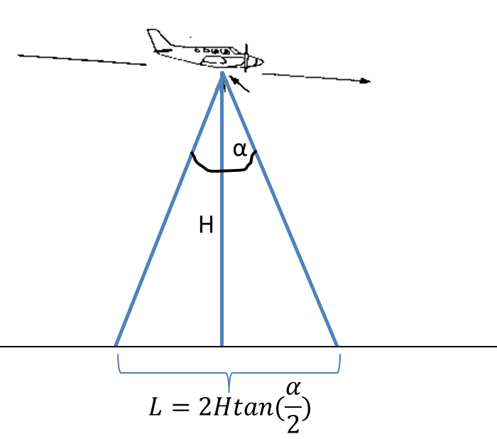

Figure 4. Illustration of a camera’s spatial footprint on the ground, as a function of field of view (fov, α) and height (H). The resolution of a pixel is Number of pixels/L. (Plane graphic adapted from <http://www.fao.org/docrep/003/t0355e/t0355e04.htm>)

Table 8: Examples of Different Pixel Options and Flight Elevations

|  |  |  |  |  |
| --- | --- | --- | --- | --- |
| **Pixels** | **Field of View** | **Elevation (m)** | **Total Meters Viewed** | **Meter Viewed per Pixel** |
| 640 | 30 | 1000 | 535.6 | 0.837 |
| 480 | 23 | 1000 | 406.7 | 0.847 |
|  |  |  |  |  |
| 640 | 30 | 100 | 53.6 | 0.084 |
| 480 | 23 | 100 | 40.7 | 0.085 |
|  |  |  |  |  |
| 7360 | 30 | 1000 | 535.6 | 0.070 |
| 4912 | 23 | 1000 | 406.7 | 0.083 |
|  |  |  |  |  |
| 7360 | 30 | 100 | 53.6 | 0.007 |
| 4912 | 23 | 100 | 40.7 | 0.008 |

Photogrammetry uses a visual camera to take images of an object or landscape from different views, and then common points of interest between the photos are mathematically intersected with a software program in order to produce a 3-dimensional image (The Basics of Photogrammetry, 2013). Therefore, additional instruments are needed to complete the photogrammetry process, including software, processors, and GPS units to track the locations of each image. Table 9 provides cost information for additional instruments for photogrammetry. These additional instruments are used on the ground and are not physically incorporated into the UAS. Therefore, with acceptable costs, all additional instruments are feasible for UAS use. Table 10 provides specifications for GPS units and accessories. All items in this table are deemed feasible as well. Other open source software, including VisualSFM Software, Ames Stereo Pipeline, GDAL, QGIS, GIMP, and Imagemagick, would be beneficial and are offered at no cost. A photogrammetry set-up is available for University of Washington students through their student technology fees (Greenberg 2013).

Table 9: Cost of Additional Photogrammetry Instruments

|  |  |
| --- | --- |
| **Additional Photogrammetry Instruments** | **Cost** |
| ERDAS Image software with Leica Photogrammetry Suite | $5,913 |
| AgiSoft Photoscan Software | $602.25 |
| 12-core processing workstation | $4k - $6k |

Additional instruments and costs gathered from Greenberg 2013.

Table 10: GPS and GPS Accessories for Photogrammetry

|  |  |  |  |  |  |
| --- | --- | --- | --- | --- | --- |
| **Model** | **Vertical Accuracy** | **Horizontal Accuracy** | **Size** | **Weight** | **Cost** |
| GeoXH**1** | 4 cm + 1.5 ppm | 2.5 cm + 1 ppm | 9.2 x 3.9 x 2.2 in | 0.925 kg | $2500 |
| Zypher 2 Antenna**1** | --- | --- | 6.35 in dia x 2.3 in height | 0.45 kg | $1450 |
| GP - 1 GPS Unit**2** | --- | --- | 2 x 1.8 x 1 in | 0.024 kg | $265 |

1: Manufactured by Trimble (<http://www.trimble.com/>)

2: Manufactured by Nikon (<http://www.nikon.com/>)

LiDAR maps the terrain of the snow survey area, which is used to determine snow depth. At this time, with weights ranging from 24 to 27 kg and costs ranging from $540,000 to $1.2 million, LiDAR is not feasible for UAS applications. Table 11 includes specifications for LiDAR instruments.

Table 11: LiDAR Specifications and Costs

|  |  |  |  |  |  |  |
| --- | --- | --- | --- | --- | --- | --- |
| **Model** | **Operational Altitude** | **Laser Wavelength** | **Laser Repetition Rate** | **Size** | **Weight** | **Cost** |
| ALTM Orion H300**1** | 150 - 4000 m | 1064 nm | 50 - 300 kHz | Sensor: 340 x 340 x 250 mm,  PDU: 415 x 100 x 100 mm | Sensor: 27 kg PDU: 6.5 kg | $900K - $1.2 mil |
| ALTM Orion M300**1** | 100 - 2500 m | 1064 nm | 50 - 300 kHz | $900K - $1.2 mil |
| ALTM Orion C300**1** | 50 - 1000 m | 1541 nm | 100 - 300 kHz | $800K - $1 mil |
|  |  |  |  |  |  |  |
| Lite Mapper 2400**2** | 10 - 200 m | 905 nm | 30 kHz | --- | 24 kg | $540K |

1: Manufactured by Optech (<http://www.optech.ca/>)

2: Manufactured by Ingenieur – Gesellschaft (<http://www.igi.eu/litemapper.html>)

Gamma radiation measures snow water equivalent (SWE) by using thallium-doped sodium, Nal(TI), crystals. At this time, with weights ranging from 91 kg to 114 kg and costs ranging from $125K to $160K, gamma radiation is not feasible for UAS applications. Table 12 includes specifications for gamma radiation instruments.

Table 12: Gamma Radiation Specifications and Costs

|  |  |  |  |  |  |  |
| --- | --- | --- | --- | --- | --- | --- |
| **Model** | **Channels** | **Detector** | **Power** | **Weight** | **Size** | **Cost** |
| RSX-5**1** | 1024 | 4+1 x 4L Nal(TI) | 9-40 VDC, 55 W | 114 kg | 28.8 x 22.46 x 11.32 in | $150K - $160K |
| RSX-4**1** | 1024 | 4 x 4L Nal(TI) | 9-40 VDC, 50 W | 91 kg | 28.8 x 22.46 x 6.97 in | $125K - $130K |

1: Manufactured by Radiation Solutions (<http://www.radiationsolutions.ca/>)

Synthetic aperture radar (SAR) measures the quantity of snow by using the instrument’s line-of-site and perpendicular azimuth to generate a two-dimensional remote sensing image. At this time, with costs ranging from $500,000 to $3 million, SAR is not feasible for UAS applications. Table 13 includes specifications for SAR instruments.

Table 13: Synthetic Aperture Radar Specifications and Costs

|  |  |  |  |  |  |
| --- | --- | --- | --- | --- | --- |
| **Model** | **Weight** | **Size** | **Frequency** | **Power** | **Cost** |
| miniSAR**1** | 30 kg | Radar Assembly: 49 cu in Gimbal Assembly: 100 cu in | Ku - Band (16.8 GHz) | 60 W | $3 mil |
|  |  |  |  |  |  |
| NanoSAR**2** | 1.5 kg | 100 cu in, 6.2 x 7.5 x 5.5 in, + antenna | X-Band (8 - 12 GHz) | 30 W | $500K |

1. Manufactured by Sandia National Laboratories (<http://www.sandia.gov/RADAR/minisar.html>)

2. Manufactured by ImSAR (<http://www.imsar.com/>)

# Manned Test Flight

## Instruments, Aircraft, Flight Details

On 14 May 2013, the research team flew two IR cameras and one visual camera on a Cessna 172 (Figure 5). The visual camera was a Point Grey Chameleon (1280x960, 1/3–in. sensor RGB CCD) with a 45-degree fov lens and polarizing filter. The IR cameras were 40-degree and 25-degree fov DRS UC640 VOx microbolometers, with 640x480 sensors sensitive to 8– to 12-micron LWIR. All cameras were attached to a mount on the belly of the Cessna (Figure 5) and were pointed straight down. The IR sensors were contained in boxes with reference temperature lids (Figure 5), which consisted of aluminum plates with embedded Dallas thermal probes (model DS18B20, -55 to 85°C, and calibrated in a calibration bath for better accuracy). The Cessna was equipped with a Novatel SPAN INS-GPS system (0.009 roll, 0.013 pitch, and 0.024 heading accuracy, RMS degrees with 1.3-m horizontal and 0.6-m vertical position accuracy). The entire system was built through a partnership between the Air-Sea Interaction group in the UW Applied Physics Lab (APL) and Regal Air and had previously been used for river, estuary, and ocean experiments.

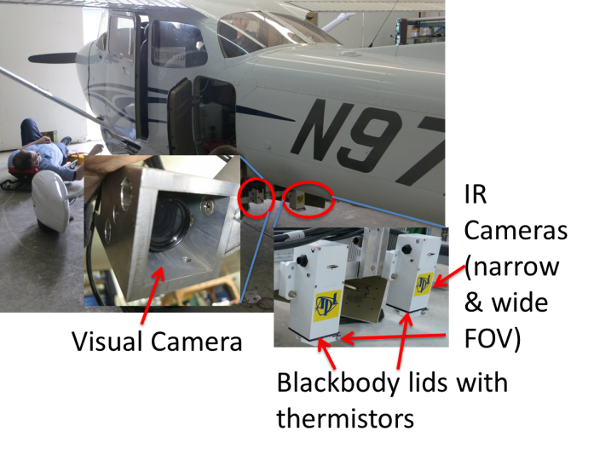

Figure 5. Photograph of Cessna 172 with insets showing the cameras and housings.

The flight path (Figure 6) was designed with two primary objectives: 1) take images in the Cascades Mountains of the Snoqualmie Pass measurement site, where several meteorological towers obtain data both for avalanche control and for observational reference for snow model comparisons; and 2) take images of snow in conjunction with many different forest types, ages, and densities in the Cedar River Watershed (which is Seattle’s water supply and managed by Seattle Public Utilities). This second area also overlapped with four NRCS SNOTEL stations (Figure 6). The team also deployed aerial snow markers at the Snoqualmie measurement site to test the aircraft camera’s ability to see them (Figure 7).

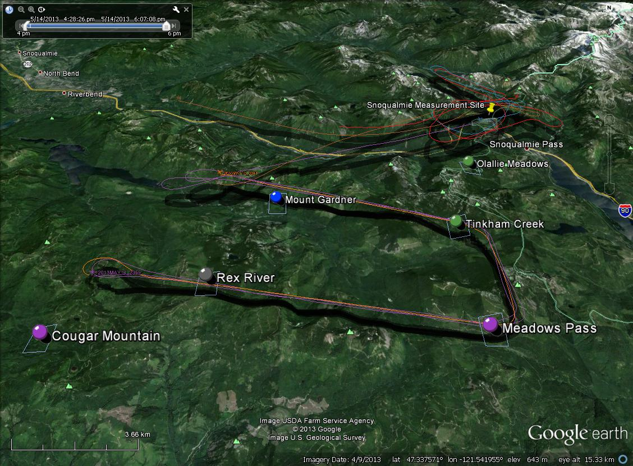

Figure 6. Map of flight paths flown on 14 May 2013. Also shown are NRCS SNOTEL stations in the region (circles) and the Snoqualmie Pass snow measurement site (thumbtack).

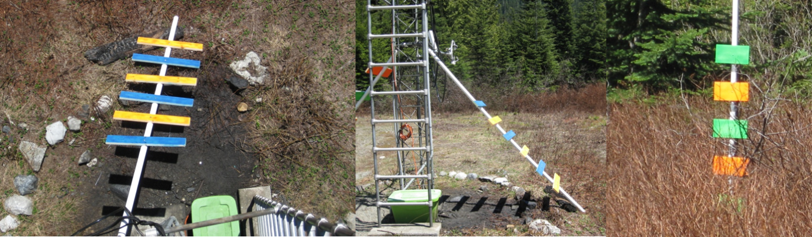

Figure 7. Aerial snow markers deployed at Snoqualmie Pass tower.

## Results

Flying over the Snoqualmie Pass snow measurement site revealed that the atmosphere between the land surface and the plane had minimal effects on the sensed snow surface temperature. In other words, the aerial camera read the same temperature as the tower-mounted IR sensor (Figure 8). However, while the tower could be seen in both the IR and the visual imagery (Figures 8c, 8d), the aerial snow depth markers could not be read. This was a function of both the low resolution of the visual camera (960 x 1280, pixels labeled in Figure 8d) and of the plane’s height above the station. Because Snoqualmie Pass is at about 900 m (3000 ft), with surrounding peaks exceeding 1750 m (5800 ft), the plane had to fly at a safe altitude in relation to the higher terrain, which kept it substantially above the measurement site.

In-flight recalibration of the microbolometers was essential because of changing plane elevations and the resulting changing temperatures of both the camera body and lens. By closing the instrument housing lids (which consisted of black bodies with a measured temperature), the researchers were able to determine an appropriate offset value for each pixel by using the following equation:



where *IR* is the measured intensity (or counts) at a given microbolometer, *g* is the gain (°C/count) calibrated in the laboratory, and *IO* is the offset, which includes corrections for the ambient temperature of the camera and lens.

Preliminary data (Figure 9) illustrate the potential of combined IR and visual imagery to better quantify the spatial snow energy balance, accounting both for local variations in snow surface temperature (e.g., the ice channels in the snowfield on the image’s right-hand-side) and for variations in longwave emissions from the surrounding terrain (e.g., trees and rocks).

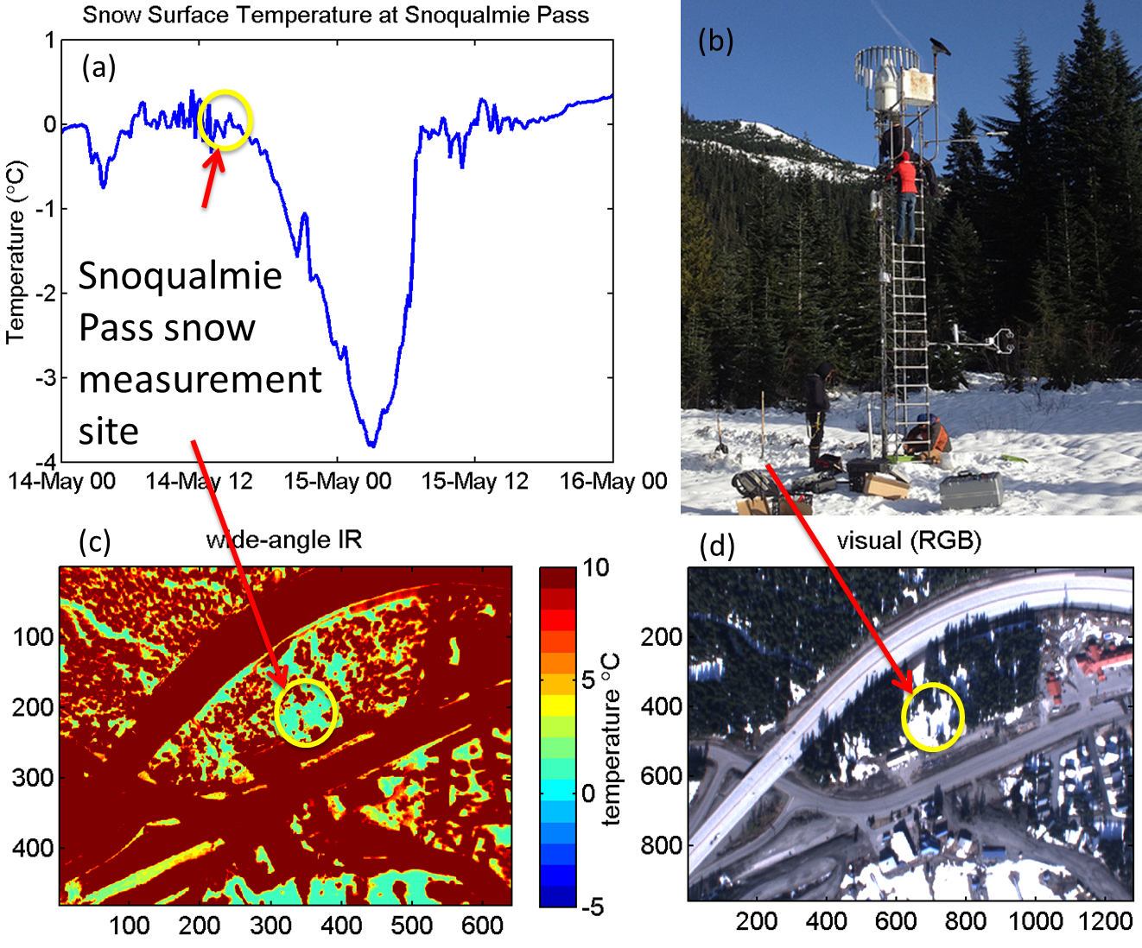

Figure 8. (a) Measurement of snow surface temperature during the fly-over from Apogee surface temperature sensor mounted on the tower shown in (b). (c) IR image and (d) visual image of the site taken from the aircraft.

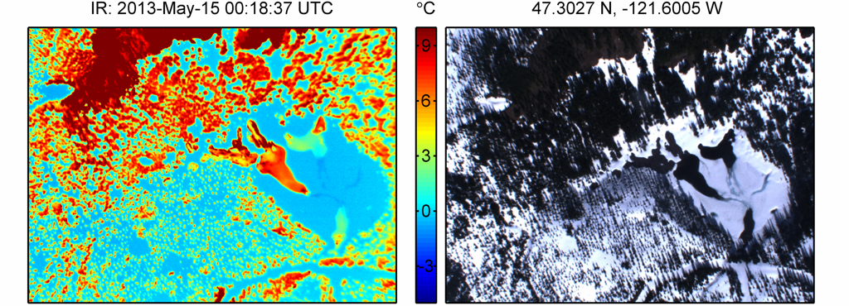

Fig.ure 9. IR (left) and Visual (right) imagery of forests, rocks, snow and ice near the Rex River SNOTEL station in the Cedar River Watershed (see Fig. 6 for approximate location), reveal a wide variability in thermal temperatures.

# Discussion

## FAA Requirements for UASs (and How They Affect Feasibility)

A significant institutional barrier for public agencies flying UASs in the United States is related to the limited ability of a UAS operator to “see and avoid” other aircraft. This concern is the main reason that the Federal Aviation Administration (FAA) requires UAS flights to obtain a Certificate of Authorization (COA) (Dalamagkidis et al. 2008, 2009) to fly in the national airspace (NAS). At this time only public agencies can obtain a COA to operate UASs in the NAS. (Private sector operators can obtain a different type of operating certificate.)

Obtaining an FAA COA application is an online process that requires several months. The application requires technical details about the aircraft; operation information about the plans for the UAS, including data and the flight area; performance information about the aircraft; and a certificate of airworthiness for the unmanned aircraft. As a public agency, the UW has an advantage in that it can certify the airworthiness of any UAS in the test. The COA, which is good for a year, stipulates a number of communications and operational protocols (FAA 2013a).

Fortunately, avalanche control and snow measurement activities typically occur over sparsely populated land, which reduces risks in terms of ground impact (Weibel and Hansman 2004), falling debris, and mid-air collision, and this simplifies justifying and obtaining a COA. Smaller or portable UASs with less mass also reduce these risks (Weibel and Hansman 2004, Anand 2007). Avalanche control and snow measurement operations, at least in Washington state, would typically occur in class G airspace, which has the lowest level of FAA regulation.

The FAA recognizes the increasing interest in civilian UAS use. The number of applications to obtain permission to fly has been steadily increasing, and the FAA has made an effort to streamline the application process and to better integrate UASs into the NAS (FAA 2013b, GAO 2013). The FAA has an Unmanned Aircraft Program Office that is specifically developing regulations and guidance for the use of UASs. This FAA office is also part of a team developing an annually updated five-year roadmap for the integration of UASs into the NAS (Joint Planning and Development Office 2012, GAO 2013).

Dalamagkidis et al. (2008, 2009), in an extensive review of the issues related to the integration of unmanned aircraft in the NAS, concluded that safety concerns will ultimately guide the regulation of UASs. The study also concluded that successful integration of UASs in the airspace will require “enabling” technology. Fortunately, a number of technology-based solutions, such as in-aircraft sensors, ground control radar systems, and transponders, are being researched or are under development (Anand 2007, UAS Vision 2013, Joint Planning and Development Office 2012).

Congress recently mandated that the FAA develop and obtain social benefits from this technology and required that the FAA develop test site programs for the “purposes of gathering safety and technical information relevant to the safe and efficient integration of UAS into the NAS”(Brito et al. 2013, GAO 2013). The FAA is also in the process of selecting six national UAS test sites from 25 applications, including a consortium from Washington state that includes the UW (FAA 2012). The availability of test areas where UASs can more routinely fly without the FAA COA process should support the development of new UAS capabilities, including snow measurement.

This federal activity suggests that permission to operate UASs may become easier to obtain both because of technological improvements and bureaucratic streamlining of the authorization processes. This, in turn, supports snow-related and environmental sensing by UASs. One possible complication is concern about UASs and privacy. This issue remains unresolved. A 2012 Government Accountability Office study noted that no federal agency has specific responsibility to regulate privacy matters relating to UASs for the federal government (GAO 2012). However, most snow-related operations tend to occur in lightly populated or unpopulated areas, which may reduce concerns about privacy.

## Further Research Needs

### Testing of the UAS

Mountain snowpack sensing with UASs needs to be tested. As discussed earlier, sensor payload integration and mission profiles are unique to aircraft type, sensor package, and mission, so there is value in testing with a candidate UAS such as Flexrotor.

Experience with visible and IR cameras on UASs, often for surveillance, is extensive. However, snowpack sensing missions have sensor data requirements that differ from surveillance missions, and in certain cases specialized hardware is required. For example, using IR sensors for snow surface temperature measurement requires additional onboard hardware for calibration. Such hardware is not available in a standard UAS IR camera package. That is why additional testing for snowpack sensing missions, even for situations when “off the shelf” sensors can be used, would doubtless provide important insights about usefulness and economics. Such analysis and testing would reveal needs specific to snowpack missions, such as operational protocols and UAS autonomy improvements for maintaining flight safety and economically gathering high quality, snowpack-specific data in mountainous terrain.

Previous research using UASs for avalanche control indicates that these aircraft have the capability to visually survey avalanche control areas before explosives are used and to drop charges to trigger controlled avalanches. In addition, the ability to use sensor on UASs to evaluate snow surfaces and snow stability could have notable value. Further research is needed to both determine if UASs can efficiently and economically complete these avalanche control tasks and also to evaluate if the existing or future regulatory environment will permit the routine use of UASs.

### Testing of the Sensors

Some of the most promising sensors for use on snow-sensing UASs, specifically IR and near-IR photography, are just starting to be used by the snow science community. Therefore, further work is needed to determine their strengths and weaknesses and how to best use them in operations. For example, are errors on the order of 2°C in actual snow surface temperature acceptable when such measurements are used to predict locations of hoar frost formation or for improving snow modeling? Preliminary data (based on model runs detailed in Wayand et al. 2013) suggest that even with 2°C errors, such data would be able to select the best model out of an ensemble of runs (Figure 10) because modeled snow surface temperature differences often vary by 10°C or more. Therefore, work is needed on measuring and using these data types from ground-based collectors before the aerial potential can be fully utilized.

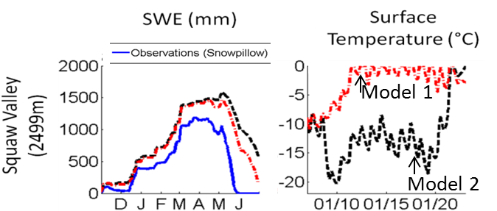

Figure 10. Snow model simulations (from Wayand et al. 2013) highlighting that in January, simulated surface temperature varies by more than 10°C at a time when simulated snow depth is identical. The model errors in the energy balance only appear in the snowpack in late May and June when melt is under way.

### T**esting by Management Agencies**

UASs could enhance a public agency’s overall operational efficiency by adding aerial surveillance capability where it would not have been previously considered because of cost, manned aircraft flight limitation, or simply the time required to set up and contract for a manned flight. For example, for resource agencies, a UAS could be used for snow measurement in the winter and spring, wildfire monitoring in the summer, and landside mapping in the fall. For a state DOT outside of the avalanche control season, UASs could provide traffic counts and surveillance along roadways where fixed cameras are not feasible.

The numerous applications for which UASs could be considered include the following:

* Forest mapping (height, density)
* Soil moisture (drought, fire)
* Forest fires and impacts (visual, IR)
* Stream temperatures (fish habitat)
* Agriculture
* Landslide mapping
* Downscaling NASA satellite images
* Identifying ecological impacts of climate or land-use change
* Search and rescue
* Transportation monitoring (volumes, roadway conditions).

# Summary

Mountain snowpack is important as both a hazard (avalanches, floods) and a resource (water supply). Therefore, snowpack monitoring is essential for predicting the times and places of avalanche hazard and to quantify the snow water equivalent (the amount of water if the snow melted) within a watershed. Currently, snow is monitored through time at point locations (avalanche snow pits and water resources SNOTEL stations), and local knowledge of spatial variation is used to extrapolate from the points to areas of interest. These methods work well as long as spatial patterns remain fixed through time, but they present difficulties when spatial variability differs from average (which occurs frequently in extreme events that matter most to society).

Aerial monitoring of the snowpack allows agencies to map spatial variations in snow properties in real time and to quantify, with repeat flights, how snow varies in space and time. The instruments most suited for mounting on a UAV, such as the Flexrotor, are visible and IR wavelength cameras. These instruments are lightweight, robust, and can map snow at less than a 1-m spatial resolution (depending on height flown and specific camera resolution). For avalanche forecasting, visible wavelength imagery can identify areas of cornice formation and verify that no people are below an avalanche control area, and IR imagery can identify spatial patterns of surface hoar formation and faceting (which lead to weak layers and avalanches following subsequent snowfall). For water resources, aerial imagery can be used to map snow presence and absence spatially across the landscape (visible wavelength), to identify snow depth from aerial markers (visible), and to map snow surface temperature (IR). Potential exists to map snow depth across the landscape by using digital photogrammetry, and researchers are beginning to investigate this technique. Snow depth is much more variable than snow density, and therefore, spatial maps of snow depth (from multiple aerial markers or photogrammetry) can be converted to spatial maps of snow water equivalent on the basis of a one-point location density measurement (available at SNOTEL sites). Snow surface temperature can be used as a snow model calibration and validation tool where snow is being modeled spatially across a watershed (as is true for most high-value Northwest watersheds). Watershed-wide snow data are critical for water resource managers to use in forecasting summer water supplies and planning hydropower operations.

Currently, SNOTEL stations provide daily snow data at fixed points. These are supplemented by monthly human snow surveys (to fill in information about spatial variability) during the spring. In California, LiDAR is being flown weekly on a test basis to fill in all spatial data for the Tuolumne River Watershed. For Washington, morning flights following clear winter nights would be ideal for mapping regions of surface hoar formation. Regular flights following storms that added substantial snowfall would be ideal for both avalanche and water resources applications, followed by weekly flights during the melt season to assess snow melt rates and snow disappearance.

**References**

Anand S. (2007). Domestic Use of Unmanned Aircraft Systems: an Evaluation of Policy Constraints and the Role of Industry Consensus Standards. Washington Internships for Students of Engineering, August 2, from http://www.wise-intern.org/journal/2007/SaurabhAnand.pdf.

Baltsavias, E.P. (1999). Airborne laser scanning: Basic relations and formulas, ISPRS Journal of Photogrammetry and Remote Sensing, 54:199–214.

Brito, J., E. Dourado, A. Thierer (2013). Mercatus Center, Unmanned Aircraft System Test Site Program George Mason University, Public Interest Comment, http://mercatus.org/sites/default/files/Brito\_Dourado\_Thierer\_Drone\_PIC-.pdf.

Bruce, J. P. (1967). Effects of new instrumentation on snow cover and precipitation networks. Available at: http://iahs.info/redbooks/a067/iahs\_067\_0038.pdf.

Bryson, M. and S. Sukkarieh (2011). A Comparison of Feature and Pose-Based Mapping Using Vision, Inertial and GPS on a UAV. In Proceedings of the 2011 IEEE/RSJ International Conference on Intelligent Robots and Systems (IROS), San Francisco, CA, USA, 25–30 September 2011; pp. 4256–4262.

Carroll, S., T. Carroll, R. Poston (1999). Spatial modeling and prediction of snow water equivalent using ground-based, airborne, and satellite snow data, Journal of Geophysical Research, 104, 19623-19629.

Carroll, T. (2001). Airborne gamma radiation snow survey program: A user’s guide. National Operational Hydrologic Remote Sensing Center. 14 pp. NOAA – NOHRSC webpage: http://www.aoc.noaa.gov/aircraft\_jet\_prop.htm.

Chiabrando, F., F. Nex, D. Piatti, and F Rinaudo (2011). UAV and RPV systems for photogrammetric surveys in archaelogical areas: Two tests in the Piedmont region (Italy). J. Archaeol. Sci., Vol. 38, pp. 697–710.

Cowles, Mary Katherine, Dale Zimmerman, Aaron Christ, and David McGinnis (2002). Combining snow water equivalent data from multiple sources to estimate spatio-temporal trends and compare measurement systems. Journal of Agricultural Biological and Environmental Statistics, Vol. 7, pp. 536-557.

Dalamagkidis, K., K. P. Valavanis, and L. A Piegl (2008). On Unmanned Aircraft Systems Issues, Challenges and Operational Restrictions Preventing Integration into the National Airspace System. Progress in Aerospace Sciences, Vol. 44, No. 7-8, pp. 503–519.

Dalamagkidis, K., K. P. Valavanis, and L. A Piegl (2009). On Integrating Unmanned Aircraft Systems into the National Airspace System, International Series on Intelligent systems control and Automation: Science and Engineering, Vol. 36. Springer Science+ Business Media.

Dandois, Jonathan P. and Erle C. Ellis (2013). High spatial resolution three-dimensional mapping of vegetation spectral dynamics using computer vision. Remote Sensing of Environment, Vol. 136, pp.259–276.

Deems, Jeffrey S., Steven R. Fassnacht, Kelly J. Elder (2006): Fractal Distribution of Snow Depth from Lidar Data. J. Hydrometeor, 7, 285–297.

Dietz, A. J. , C. Kuenzer , U. Gessner and S. Dech (2012). Remote sensing of snow – a review of available methods, International Journal of Remote Sensing, 33:13, 4094-4134.

Dozier, J., Schneider, S. R., & McGinnis, D. F. (1981). Effect of grain size and snowpack water equivalence on visible and near‐infrared satellite observations of snow. *Water Resources Research*, *17*(4), 1213-1221.

Dozier, J., and T. Painter (2004). Multispectral and hyperspectral remote sensing of alpine snow properties. Annual Review Earth Planet Science, 32, 465–494.

Dozier, J., and S.G. Warren (1982). Effect of viewing angle on the infrared brightness temperature of snow. Water Resources Research, *18*(5), 1424-1434

Dunford, R., Michel, K., Gagnage, M., Piégay, H., & Trémelo, M. L. (2009). Potential and constraints of Unmanned Aerial Vehicle technology for the characterization of Mediterranean riparian forest. *International Journal of Remote Sensing*, *30*(19), 4915-4935.

FAA (2012). Unmanned Aircraft System Test Site Program, Docket FAA-2013-0061, http://www.gpo.gov/fdsys/pkg/FR-2013-02-22/html/2013-03897.htm, accessed June 2013.

FAA (2013a). Certificate of Authorization or Waiver (COA), Systems Operations Service, http://www.faa.gov/about/office\_org/headquarters\_offices/ato/service\_units/systemops/aaim/organizations/uas/coa/, accessed June 2013.

FAA (2013b). Unmanned Aircraft Systems (UAS), Policies and Initiatives, http://www.faa.gov/about/initiatives/uas/. Accessed June 2013.

FLIR (2013). Retrieved March 2013, from http://www.flir.com/US/.

FLIR. (2013). How Does an IR Camera Work? Retrieved June 10, 2013, from http://www.flir.com/thermography/americas/us/view/?id=55706.

Fonstad, Mark A., James T. Dietrich,1 Brittany C. Courville,2 Jennifer L. Jensen2 and Patrice E. Carbonneau (2013). Topographic structure from motion: a new development in photogrammetric measurement. Earth Surf. Process. Landforms, 38, 421–430

Foster, J. L., D.K. Hall, A.T.C. Chang, and A. Rango (1984). An overview of passive microwave snow research and results. Reviews of Geophysics, Vol. *22*(2), pp. 195-208.

GAO (2012). Unmanned Aircraft Systems: Measuring Progress and Addressing Potential Privacy Concerns Would Facilitate Integration into the National Airspace System [Reissued on September 18, 2012] GAO-12-981, Sep 14, 2012, http://www.gao.gov/products/GAO-12-981, Accessed June 2013.

GAO (2013).Unmanned Aircraft Systems: Continued Coordination, Operational Data, and Performance Standards Needed to Guide Research and Development GAO-13-346T, Feb 15, 2013, <http://www.gao.gov/products/GAO-13-346T>,

Greenberg, H. (2013). Enabling Photogrammetry at UW Proposal. Seattle: University of Washington.

Hall, D. K., G. A. Riggs, and V. V. Salomonson (2006). MODIS/Terra Snow Cover Daily L3 Global 500m Grid V005.

Hannaford, J.F. (1960). A proposal for incorporating aerial snow-depth markers into water supply forecasts. 28th Annual Western Snow Conference.

[Henderson T.J](http://www.westernsnowconference.org/biblio?f%5bkeyword%5d=1294&f%5bauthor%5d=397). (1953). [The use of aerial photographs of snow depth markers in water supply forecasting](http://www.westernsnowconference.org/node/1573). 21st Annual Western Snow Conference.

Hopkinson, C., M. Sitar, L. Chasmer, and P. Treltz (2004). Mapping snopack depth beneath forest canopies using airborne LiDAR. Photogrammetric engineering and remote sensing, 70(3), 323-330.

Howard, R., and R. Stull (2013). IR radiation from trees to a ski run -- a case study. J. Appl. Meteor. Climatol. doi:10.1175/JAMC-D-12-0222.1, in press.

Ibarra-Castanedo C. (2005). “Quantitative subsurface defect evaluation by pulsed phase thermography: depth retrieval with the phase,” Ph. D. thesis, Laval University. [accessible online: http://www.theses.ulaval.ca/2005/23016/23016.pdf].

ImSAR (2013). Retrieved March 2013, from http://www.imsar.com/.

Ingenieur – Gesellschaft (2013). Retrieved March 2013, from http://www.igi.eu/litemapper.html.

Järnstedt, J., A. Pekkarinen, S. Tuominen, C. Ginzler, M. Holopainen, and R. Viitala (2012). Forest variable estimation using a high-resolution digital surface model, ISPRS Journal of Photogrammetry and Remote Sensing 74 (2012) 78–84.

Joint Planning and Development Office (2012). Next Generation Air Transportation System Unmanned Aircraft Systems Research, Development and Demonstration Roadmap, March 15, http://www.jpdo.gov/library/20120315\_UAS%20RDandD%20Roadmap.pdf

Jet Propulsion Laboratory (JPL) 2013, Press Release: NASA Opens New Era in measuring western U.S. Snowpack, <http://www.jpl.nasa.gov/news/news.php?release=2013-154>.

Julander, R. (2012). Automated Aerial Markers Piolot Project . NRCS National Water & Climate Center Snow News, 2.

Julander, R. (2013). Snow Survey Supervisor. NRCS. Personal Interview. 10 June 2013.

Laliberte, A.S., M.A. Goforth, C.M. Steele, and A. Rango (2011). Multispectral remote sensing from unmanned aircraft: Image processing workflows and applications for rangeland environments. Remote Sens., Vol. 3, pp. 2529-2551.

Matzl, M., and M. Schneebeli (2006). Measuring specific surface area of snow by near-infrared photography. Journal of Glaciology, *52*(179), 558-564.

McCormack, E. D. (2008). The Use of Small Unmanned Aircraft by the Washington State Department of Transportation. TRAC/University of Washington report 10, WA-RD 607.1. <http://www.wsdot.wa.gov/research/reports/fullreports/703.1.pdf>. Accessed June 2013.

McCormack, E. D. (2009). “Exploring Transportation Application of Small Unmmaned Aircraft” ITE Journal, December. Pp 32 Vol. 79 (12).

McCormack, E. D. and J. Stimberis (2010). Evaluating Use of Small Unmanned Aircraft for Avalanche Control. Transportation Research Record 2169 Maintenance Services and Surface Weather, 168-173.

McCormack, E. D. and J. Stimburis (2010a). Small Unmanned Aircraft Tested for Use in Avalanche Control, The Avalanche Review: A Publication of the American Avalanche Association, Vol. 28, No. 4 April.

Miller, R., and O. Amidi (1998). 3-D Site Mapping with the CMU Autonomous Helicopter 3-D Site Mapping with the CMU Autonomous Helicopter. In Proceedings of the 5th International Conference on Intelligent Autonomous Systems, Sapparo, Japan.

[Miller RW](http://www.westernsnowconference.org/biblio?f%5bkeyword%5d=1013&f%5bauthor%5d=1210). (1962). [Aerial snow depth markers configuration and installation](http://www.westernsnowconference.org/node/1227). 30th Annual Western Snow Conference [Internet].

Morin, S., Y. Lejeune, B. Lesaffre, J.-M. Panel, D. Poncet, P. David, and M. Sudul (2012). An 18-yr long (1993–2011) snow and meteorological dataset from a mid-altitude mountain site (Col de Porte, France, 1325 m alt.) for driving and evaluating snowpack models. Earth System Science Data, Vol. 4(1), pp. 13–21, doi:10.5194/essd-4-13-2012.

Nagler, T., and H. Rott (2000). Retrieval of wet snow by means of multitemporal SAR data. Geoscience and Remote Sensing, IEEE Transactions on, *38*(2), 754-765.

National Resources Conservation Service (2011). Washington Cooperative Snow Survey and Water Supply Forecasting Program Water Year 2012 Snow Survey Measurement Schedule.

National Resources Conservation Service (2013). Personal communication with Scott Pattee (Washington State Chief) and Randy Julander (Utah State Chief) regarding flights and costs.

Nghiem, S.V. and W.-Y. Tsai (2001). Global snow cover monitoring with spaceborne Ku-band scatterometer. *IEEE Trans. Geosci.* *Remote Sens.,* **39**(10), 2118–2134.

Nikon (2013). Retrieved June 2013, from http://www.nikon.com/.

Nolin, A. W. (2010). Recent advances in remote sensing of seasonal snow. *Journal of Glaciology*, *56*(200), 1141-1150.

Optech (2006). Retrieved March 2013, from http://www.optech.ca/.

Painter, T. H., K. Rittger, C. McKenzie, P. Slaughter, R. E. Davis, and J. Dozier (2009). Retrieval of subpixel snow covered area, grain size, and albedo from MODIS. R. Sen.of Env., Vol. 113, pp. 868–879.

Pattee, Scott (2013). Water Supply Specialist. NRCS. Personal Interview. 8 April 2013.

Pollock, D. H. (1965). Photogrammetric mapping of the Marmot Creek snowfield, Prairie Farm Rehabilitation Administration, Regina, January 1965.

Pulliainen, J. *and 7 others*. (2004). Estimation of snow pack characteristics and snow covered area in boreal forests from ERS-2 SAR and Envisat ASAR data. *In IGARSS 2004. 24th* *International Geoscience and Remote Sensing Symposium,* *20–24 September 2004, Anchorage, Alaska, USA. Proceedings,* *Vol. 6*. Piscataway, NJ, Institute of Electrical and Electronics Engineers, 3680–3683.

Radiation Solutions (2007). Retrieved April 2013, from <http://www.radiationsolutions.ca/>.

Rott, H., S. H. Yueh, D. W. Cline, C. Duguay, R. Essery, C. Haas, F. Hélière, M. Kern, G. Macelloni, E. Malnes, T. Nagler, J. Pulliainen, H. Rebhan, A. Thompson, (2010). Cold Regions Hydrology High-Resolution Observatory for Snow and Cold Land Processes. Proceedings of the IEEE, 752-765.

Salisbury, J. W., D'Aria, D. M., & Wald, A. (1994). Measurements of thermal infrared spectral reflectance of frost, snow, and ice. *Journal of Geophysical Research: Solid Earth (1978–2012)*, *99*(B12), 24235-24240.

Sandia National Laboratories (2005). Retrieved March 2103, from http://www.sandia.gov/RADAR/minisar.html.

Shea, C. and B. Jamieson (2011). Some fundamentals of handheld snow surface thermography, *The Cryosphere*, 5, 55–66.

Sierra-Olympic Technologies (2009). Retrieved March 2013, from http://sierraolympic.com/.

Sturm, M., Taras, B., Liston, G. E., Derksen, C., Jonas, T., & Lea, J. (2010). Estimating snow water equivalent using snow depth data and climate classes. Journal of Hydrometeorology,Vol. *11*(6), pp. 1380-1394.

Sugiura, R., N. Noguchi, and K. Ishii (2005). Remote-sensing technology for vegetation monitoring using an unmanned helicopter. Biosyst. Eng, Vol. 90, pp. 369–379.

Tape, K. D., N. Rutter, H.P. Marshall, R. Essery, and M. Sturm (2010). Recording microscale variations in snowpack layering using near-infrared photography, Journal of Glaciology, 56(195), 75-80.

The Basics of Photogrammetry (2013). Retrieved June 14, 2013, from Geodetic Systems: http://www.geodetic.com/v-stars/what-is-photogrammetry.aspx.

Trimble (2013). Retrieved June 2013, from http://www.trimble.com/.

UAS Vision (2013). a global forum for the unmanned aircraft systems community, (Web Site) http://www.uasvision.com/category/technology/, accessed June, 2013

Vogel, S. W. (2002). Usage of high-resolution Landsat 7 band 8 for single-band snow-cover classification. Annals of Glaciology, Vol. 34(1), pp. 53–57.

Wallace, L. A. Lucieer, C. Watson, and D. Turner, (2012). Development of a UAV-LiDAR System with Application to Forest Inventory. Remote Sens. 2012, 4, 1519-1543;

Wang, L., C. Derksen and R. Brown. (2008). Detection of pan-Arctic terrestrial snowmelt from QuikSCAT, 2000–2005. *Remote Sens.* *Environ.,* **112**(10), 3794–3805.

Wayand, N. E., A. F. Hamlet, M. Hughes, S. Feld, and J. D. Lundquist (2013). Intercomparison of Meteorological Forcing Data from Empirical and Mesoscale Model Sources in the N.F. American River Basin in northern California*, Journal of Hydrometeorology*, 14, 677–699.

Weibel, R. E. and R. Hansman (2004). Safety Considerations for Operation of Unmanned Aerial Vehicles in the National Airspace System, In AIAA 4th Aviation Technology, Integration and Operations (ATIO) Forum, Sep. 20-22, America Institute of Aeronautics and Astronautics, 2006-11-21.

Welty, E.Z., T.C. Bartholomaus, S. O’Neel and W.T. Pfeffer (2013). Journal of Glaciology, Vol. 59, pp. 275-286.

Westoby, M.J., J. Brasington, N.F. Glasser, M.J. Hambrey, and J.M. Reynolds (2012). ‘Structure-from-Motion’ photogrammetry: A low-cost, effective tool for geoscience applications. Geomorphology, Vol. 179, pp. 300–314.

Winter Alpine Engineering (2004). Avalanche Hazard Reduction using the Doppelmayr “Avalanche Guard” Cache and Mortar Technology, Final Report, August <http://www.dot.state.wy.us/webdav/site/wydot/shared/Public%20Affairs/research%20reports/Doppelmayr%20Avalanche%20Guard%20Chache%20and%20Mortar%20Technology.pdf>, accessed June 2013.

Wiscombe, W.J. and S. G. Warren (1980). A model for the spectral albedo of snow, I, pure snow. J. Atmos. Sci., 37: 2712-33.

WSDOT (2008). Storm related closures of I-5 and I-90. Freight Transportation Economic Impacts Assessment Report WA-RD 708.1 <http://www.wsdot.wa.gov/NR/rdonlyres/8FCFF2CF-4ACC-461A-96A6-AA310CCF6050/0/WSDOT_I5_90ClosuresFinalReport.pdf>, accessed June 2013.

WSDOT (2013). Snoqualmie Pass Closure and Snowfall Records, website: [http://](http://www.wsdot.wa.gov/winter/snoqualmie/)www.wsdot.wa.gov/winter/snoqualmie.

WSDOT (2013a). SR 20 — North Cascades Highway — Frequently Asked Questions <http://www.wsdot.wa.gov/Traffic/Passes/NorthCascades/FAQ.htm#8>, accessed June 2013

WSDOT (2013b). Snoqualmie Pass Closure and Snowfall Records, Web Site: <http://www.wsdot.wa.gov/winter/snoqualmie/>, accessed June 2013.